 Viewing and Printing W2/W2Cs

Begin by navigating to the View W-2/W-2c Forms page by clicking on the “View W-2/W-2c Forms” tile

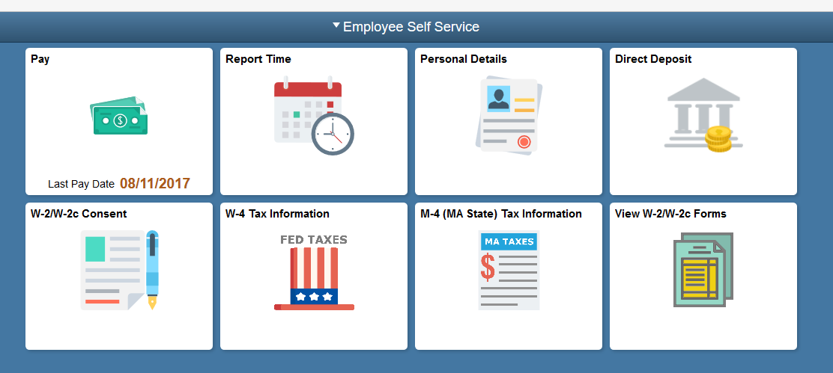

To reduce your security risk, please enter the last four digits of your Social Security Number. 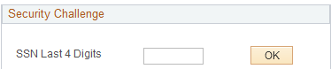
Use the View W-2/W-2c Forms page to view and/or print your forms.

Note: In the event that a correction to your W-2 is required you will see a W-2c.
You will select the form for a particular tax year.

Click the View a Different Tax Year link.
Use the Select Tax Year page to select the particular year. UMass provides the forms beginning with 2009.
Return to the View W-2/W-2c Forms page.

Click the View W-2/W-2c Forms link in the menu bar.
Click the Year End Form link.
Your W-2 Wage and Tax Statement opens in a new window.
You can view your W-2 Wage and Tax Statement. If you wish, you can print the statement using your local computer and printer.
Click the Close button.
Click the UMASS W2 Information link.
You can view the W2 Information page. If you wish, you can print the statement using your local computer and printer.
The Tax Reporting information page displays in a new window.
Click the Close button.
Congratulations! You have successfully viewed and printed your W-2 form.
End of Procedure.

